Contract: 2020/ 417-305

Project: Reform of National Disability Determination System

FINAL REPORT
1 October 2020 – 30 November 2025

Podgorica, May 2026

Table of contents

List of Abbreviations 3
Summary of the Action 4
Results achieved 6
Activities carried out during project implementation 11
RESULT AREA 1: Legal Framework 13
Result Area 2: Institutional rightsizing and reorganization 17
DIFFICULTIES ENCOUNTERED AND MEASURES TAKEN TO OVERCOME PROBLEMS AND EVENTUAL CHANGES INTRODUCED 22
Visibility and Communication 24
Summary of resources deployed during the Action 27
Annexes 28

List of Abbreviations

DEU | Delegation of European Union
OPD | Organisation of Persons with Disabilities
MFSS | Ministry of Finance and Social Welfare
MoLSW | Ministry of Labor and Social Welfare
MoSFD | Ministry of Social Welfare, Family Care and Demography
UN CRPD | UN Convention on the Rights of Persons with Disabilities
IWG | Intersectoral Working Group established by the MFSS
SC | Steering Committee
MED | Ministry of Economic Development
MJHMR | Ministry of Justice, Human and Minority Rights
NGO | Non-Governmental Organizations
IPH | Institute for Public Health
UNDP | United Nations Development Programme
CfP | Call for Proposal
C&V Plan | Communication and Visibility Plan

Summary of the Action

The project Reform of the National Disability Determination System was designed to support the Government of Montenegro in implementing a comprehensive structural reform of the national disability assessment and determination system, in line with the UN Convention on the Rights of Persons with Disabilities (UN CRPD). The Action aimed to transform the existing fragmented and predominantly medical-based model into a unified, functional and human-rights-based system focused on individual capacities, environmental barriers and support needs.
The reform addressed long-standing systemic challenges in Montenegro’s disability determination framework. Disability assessment procedures are conducted by more than 35 commissions operating across five different sectors — social protection, employment, pension and disability insurance, veterans’ protection and education — each applying separate criteria, methodologies and procedures. Such fragmentation frequently resulted in inconsistent decisions, unequal treatment of persons with disabilities, duplication of procedures and excessive administrative burden for beneficiaries and their families.
The overall objective of the Action was to ensure more just, equal and easier access to disability-related rights, cash benefits and services for persons with disabilities in Montenegro. The specific objective was to reform the national disability determination system through the development of a unified legal and methodological framework, establishment of a specialized institution for disability assessment, strengthening of institutional capacities and promotion of a human-rights-based approach to disability.
This report was finalized in May 2026 in line with donor reporting requirements and includes final legislative and institutional developments completed during the project implementation and closure period from 1 October 2020 until 30 November 2025, by the United Nations Development Programme (UNDP), in partnership with the Government of Montenegro and with financial support of the European Union in the total amount of EUR 1 million. Due to the complexity of the reform process, prolonged legislative procedures and frequent institutional restructuring caused by political changes, the Action was extended twice, resulting in a total implementation period of 62 months.
The Action focused on two interrelated result areas:
1. Development and adoption of unified national criteria and methodology for disability assessment, based on the International Classification of Functioning, Disability and Health (ICF), WHODAS methodology and the principles of the UN CRPD;
2. Institutional restructuring of the disability determination system through the establishment of a single specialized institution — the Institute for Disability Assessment — intended to replace the fragmented system of sectoral commissions.
During implementation, the Action achieved substantial and systemic results in establishing the legal, methodological and institutional foundations for a comprehensive reform of Montenegro’s disability determination system. As noted in the independent final evaluation, the project initiated a “structural and irreversible transformation” of the national disability determination framework by replacing a fragmented, medically based approach with a unified, functional and human-rights-based model aligned with the UN CRPD.
The Parliament of Montenegro adopted the Law on Uniform Disability Assessment together with amendments to seven sectoral laws regulating social protection, education, labour and employment, pension and disability insurance, veterans’ protection and benefits for persons with disabilities. This comprehensive legislative package represents the most significant reform in the area of disability assessment in Montenegro to date, establishing standardized and person-centred procedures for disability assessment across all relevant sectors and creating the legal basis for the establishment of a single national Institute for Disability Assessment.
In parallel with the legislative reform, the Action supported the development of a comprehensive disability assessment methodology and all key accompanying by-laws and operational tools required for implementation of the new system. Premises for the future Institute for Disability Assessment were reconstructed and fully equipped, while extensive intersectoral coordination mechanisms and cooperation among institutions were established and maintained throughout the implementation period. An important contribution of the Action was also the continuous and meaningful participation of organizations of persons with disabilities (OPDs), which significantly “strengthened the legitimacy, transparency and accountability of the reform process”. The final evaluation recognized participation of OPDs as one of the key factors contributing to the credibility and sustainability of the reform.
A particularly important achievement and added value of the Action was the development of the first comprehensive disability assessment methodology in Montenegro fully aligned with the human-rights-based approach to disability and international standards established by the WHO International Classification of Functioning, Disability and Health (ICF) and the UN CRPD. In addition to the List of Impairments and List of Functional Limitations, the Action supported the development of a Needs Assessment Questionnaire aimed at identifying individual support needs of persons with disabilities and enabling evidence-based planning of future services and benefits. This represented a major shift from assessing disability solely through medical diagnoses towards a model focused on functioning, participation, environmental barriers and individualized support.
Once operational, the new system is expected to significantly reduce administrative burden for persons with disabilities and their families, ensure more consistent and transparent decision-making and facilitate equal access to rights and services across sectors.
While several operational components of the reform — including full deployment of the information system, piloting activities and complete operationalization of the Institute — will continue beyond the duration of the Action as summarized in the table below, the project successfully established all legal, institutional and technical preconditions necessary for implementation of the new system.

Reform Component | Status at Project Closure
Law on Uniform Disability Assessment adopted | Completed
Amendments to seven sectoral laws adopted | Completed
Disability assessment methodology developed | Completed
By-laws prepared | Completed
Institute premises adapted and equipped | Completed
Institute formally established | Initiated
Institute staffing and operationalization | Pending post-Action implementation
Information system technical specifications prepared | Completed
Information system deployment | Pending
Staff training | Pending
Piloting of new procedures | Pending
Communication and visibility activities | Completed

Sustainability of the reform has been further strengthened through the follow-up agreement between the Ministry of Social Welfare, Family Care and Demography and UNDP for the second phase of support, covering the period 2025–2028. Building on the results of this Action, the second phase will focus on operationalization of the Institute for Disability Assessment, digitalization of the assessment process, capacity development and introduction of the Inclusive Allowance, thereby ensuring continuity of reform implementation within national systems and in line with Montenegro’s Reform Agenda, EU accession priorities and the UN CRPD.
The Action represents one of the most comprehensive disability sector reforms undertaken in Montenegro to date and provides a strong foundation for continued implementation of a modern, inclusive and sustainable disability determination system in line with European standards and the UN CRPD.

Results achieved

During project implementation, the following results were achieved in reference to the Logical Framework:
 | Results chain | Indicators | Baseline (incl.ref.) | Current value Reference date: July 31, 2019. | Targets (incl. reference year) | Sources and means of verification | Results and clarifications
Overall objective: Impact | Overall objective:  More just, equal and easier access to all rights (cash benefits and services) for persons with disabilities | New assessment and determination system set in place and functioning | 2017:  New assessment and determination model in place | 2019:  New assessment and determination model in place | 2025:  New national human rights model developed and applied within a new unified system of assessment and determination | Government reports:  Action Progress Report  Report on implementation of National Strategy on person with disabilities | Partially achieved. The legal, methodological and institutional foundations of the new system were established; however, full operationalization will continue during the post-project phase.
Specific objectives: Outcomes | Specific objective:  National Disability Determination System reformed.  Result 1. Development and adoption of new criteria for disability determination.  Result 2. Institutional rightsizing reorganization – by downsizing of current 30 commissions to one unique Commission. | New functionality-based model criteria developed and adopted, at national level  The national, unique Commission/Institute legally established and performing its scope of work | 2017:  Separate assessment and determination procedures taking place in different sectors within 30 commissions | 2019:  Separate assessment and determination procedures taking place in different sectors within 30 commissions | 2025:  New unified assessment and determination system with sophisticated Information System for cases processing – put into operation | Government reports  Laws and by-laws adopted in the Parliament and published in the Official Gazette of Montenegro  Action Progress Report on implementation of National Strategy on person with disabilities | Partially achieved  The new model is developed and adopted at the national level. The legal basis for establishment of the Institute was adopted, while operational establishment and staffing are expected during the post-project phase.  Development and deployment of the information system was postponed due to delayed adoption of the legal framework. Technical specifications and hardware procurement were completed, providing the basis for implementation during the post-project phase.
Outputs | 1.1. Multi-sectoral Task-force work group established and functioning | 1.1.1.  No. of meetings with written minutes records | 2017:  No multi/cross sectoral coordination mechanism dealing with assessment and determination  Baseline: 0 | 2019:  No multi/ cross sectoral bodies dealing with assessment and determination is in place  Current value: Task-force group established. | 2025:  Intersectoral Working Group established.  Target: nine meetings of Task-force group in the course of the Action | Official decision on the establishment of the Multi-sectoral Task-force work group (MLSW)  Reports, meeting minutes, progress track records and decisions | Achieved
Outputs | 1.2. Comprehensive, unified List of Impairments, List of Functional Limitations and national uniformed Criteria developed | 1.2.1.  Comprehensive list available  1.2.2 New national uniform criteria available | 2017:  Different lists and criteria applied in the five sectors for disability assessment and determination.  Baseline: 0 | 2019:  Different lists and criteria applied in the five sectors for disability assessment and determination.  Current value: 0 | 2024:  Comprehensive, unified List of Impairments, List of Functional Limitations and national uniform criteria developed Target: both docs adopted. | Government reports.  Official Gazette of Montenegro | Achieved  All documents developed
Outputs | 1.3. New law(s) and bylaw(s) adopted | New law(s) and by-laws enforced. | 2017:  There are 6 laws and 27 bylaws regulating the area  Baseline: 0 | 2019:  There are 6 laws and 27 bylaws regulating the area  Current value: 0 | 2025:  Target: revisions of the 6 laws and 27 by-laws. The new law and by-laws on assessment and determination criteria & establishment of Institute for disability assessment adopted | Official Gazette of Montenegro | Achieved  The Law on Uniform Disability Assessment was adopted together with amendments to 7 sectoral laws. Bylaws are prepared for adoption.
Outputs | 2.1 Commission established, staffed and supported | 2.1.1. Number of professional and administrative staff hired  2.1.2. Number of assessments procedures carried out monthly  2.1.3. Number of issues reported and resolved  2.1.4. Number of consultative meetings held | 2017: No Commission/Institute  2.1.1. Number of professional and administrative staff hired  Baseline: 0  2.1.2. Number of assessments procedures carried out monthly  Baseline: 0  2.1.3. Number of issues reported and resolved  Baseline: 0  2.1.4. Number of consultative meetings held  Baseline: 0 | 2019: No Commission/Institute  2.1.1. Number of professional and administrative staff hired  Current value: 0  2.1.2. Number of assessments procedures carried out monthly  Current value: 0  2.1.3. Number of issues reported and resolved  Current value: 0  2.1.4. Number of consultative meetings held  Current value: 0 | 2025: Commission/Institute established and functioning  2.1.1. Target: 30 staff professional and administrative staff hired  2.1.2. Target: 300 assessments procedures carried out in the first 3 months  2.1.3. Target: 5 issues reported and resolved in initial month  2.1.4. Target: Four consultative meetings held in initial 2 months | By-law on institutional establishment and systematization of the workplaces/staffing  Project progress reports  Staff performances data from the Information System of the Commission  Consultative meetings minutes and obligatory conclusions | Not completed within the duration of the Action due to dependency on adoption and operationalization of the legal framework. Formal decision on Institute establishment adopted in December 2025. Remaining operationalization activities will continue during the post-Action implementation phase under the responsibility of the competent institutions.
Outputs | 2.2. Premises adapted and equipped | 2.2.1. Number of premises adapted  2.2.2. Number of pieces of equipment procured and delivered | 2017: No Commission/Institute  2.2.1. Number of premises adapted  Baseline: 0  2.2.2. Number of pieces of equipment procured and delivered  Baseline: 0 | 2019: No Commission/Institute  2.2.1. Number of premises adapted  Current value: 0  2.2.2. Number of pieces of equipment procured and delivered  Current value: 0 | 2024: Commission/Institute established and functioning  2.2.1. Number of premises adapted  Target: 1  2.2.2. Number of pieces of equipment procured and delivered  Target: 150 | Official Gov.'s Decision on the premises allocation  Technical works hand-over documentation and reports  Equipping | Achieved  Premises were adapted, equipment procured and delivered
Outputs | 2.3. Civil servants trained for application of the new assessment and determination system | 2.3.1. Number of civil servants and experts trained  2.3.2. Number of civil servants and expert participating in study visits | 2017: Civil servants and experts not trained to apply the new assessment and determination criteria  2.3.1. Number of civil servants and experts trained  Baseline: 30  2.3.2. Number of civil servants and expert participating in study visits  Baseline: 10 | 2019: Civil servants and experts not trained to apply the new assessment and determination criteria  2.3.1. Number of civil servants and experts trained  Current value: 0  2.3.2. Number of civil servants and expert participating in study visits  Current value: 0 | 2025:  Conducted trainings for practitioners on the application of the new unified human-rights-based criteria and methodology for disability assessment.  Target: 50 civil servants and experts trained (~50% women)  Two study visits conducted  Target: 10 participants | Training programs and materials developed  Participation lists records  Study visit reports with lessons learned | Not completed within the duration of the Action due to dependency on adoption and operationalization of the legal framework.
Outputs | 2.4. Persons with disabilities and wider public duly informed about the new assessment and determination system | 2.4.1. Number of campaign activities implemented  2.4.2. Number of topics covered  2.4.3. Number of organizations involved  2.4.4. Number of persons targeted by the campaigns | 2017: Several OPDs supported to advocate and lobby for the new model. Persons with disabilities, caregivers and wider public not acquainted with the new model.  2.4.1. Number of campaign activities implemented  Baseline: 0  2.4.2. Number of topics covered  Baseline: 0  2.4.3. Number of organizations involved  Baseline: 0  2.4.4. Number of persons targeted by the campaigns  Baseline: 0 | 2019: Several OPDs lobbying for the new model.  Wider public not acquainted with the new model.  2.4.1. Number of campaign activities implemented  Current value: 0  2.4.2. Number of topics covered  Current value: 0  2.4.3. Number of organizations involved  Current value: 0  2.4.4. Number of persons targeted by the campaigns  Current value: 0 | 2025:  2.4.1. Number of campaign activities implemented - Target: 10  2.4.2. Number of topics covered - Target: 6  2.4.3. No. of persons with disabilities associations involved in the campaigns – Target: 5  2.4.4. The five sectors’ scopes of work covered and over 100.000 persons targeted by the campaign. Target: 100.000 persons | Campaigns documentation  Campaigns records & statistics | Achieved  A national conference and three regional info days were organized. Second call was not published, but funds are allocated to info days in Podgorica (80 participants), Bijelo Polje (56 participants) and Bar (30 participants). Q&A material is being prepared, and media campaign is finalized. Media campaign products will also be available for use during the post Action period.
Outputs | 2.5. Information System developed and implemented | 2.5.1. System developed, tested, staff trained & put into operation.  2.5.2. Number of institutions connected to the information system  2.5.3. Number of new entries into the system  2.5.4. Number of persons with disabilities with personal records in E-Registry | 2017: Information System not in place  2.5.1. System developed, tested, staff trained & put into operation.  Baseline: 0  2.5.2. Number of institutions connected to the information system.  Baseline: 0  2.5.3. Number of new cases entries into the system  Baseline: 0  2.5.4. Number of person with disabilities with personal records in E-Registry  Baseline: 0 | 2019: Information system not in place  2.5.1. System developed, tested, staff trained & put into operation.  Current value: 0  2.5.2. Number of institutions connected to the information system  Current value: 0  2.5.3. Number of new entries into the system  Current value: 0  2.5.4. Number of persons with disabilities with personal records in E-Registry  Current value: 0 | 2025: IS in place.  2.5.1. System' Acceptance Test verified.  2.5.2. Interoperability established with four IS of other institutions  2.5.3. On average 200 cases processed monthly in the initial 3 months through the IS  2.5.4. All new Commission staff trained to operate in new IS.  Social welfare staff trained to operate by new procedure in Social Card – ISWS. | Information System with module for Registry of person with disabilities developed and put into operation. | Not completed within the duration of the Action due to dependency on adoption and operationalization of the legal framework. Detailed technical specifications for the development of the information system were prepared, and hardware for the Institute for Uniform Disability Assessment was procured.
Outputs | 2.6. Piloting of the new assessment and determination system performed | 2.6.1. Number of individual cases determined  2.6.2. Number of procedures analyzed  2.6.3. Analytical report with recommendations available  2.5.4. New system Impact assessment | 2017: New system not in place  2.6.1. Number of individual cases determined.  Baseline: 0  2.6.2. Number of procedures analyzed  Baseline: 0  2.6.3. Analytical report with recommendations available  Baseline: 0  2.5.4. New system Impact assessment  Baseline: 0 | 2019: New system not in place nor the Information system  2.6.1. Number of individual cases determined.  Current value: 0  2.6.2. Number of procedures analyzed  Current value: 0  2.6.3. Analytical report with recommendations available  Current value: 0  2.5.4. New system Impact assessment  Current value: 0 | 2025:  2.6.1. All the work-procedures analyzed (application, processing, individual decisions issuance & referrals) to all five sectors – 40 cases.  2.6.2. One analytical report with recommendations produced  2.6.3. One impact assessment report produced | Pilot Phase Analytical report with adjustments recommendations  Impact assessment report | Not completed within the duration of the Action due to dependency on adoption and operationalization of the legal framework.

Activities carried out during project implementation

This report summarizes activities implemented throughout the entire duration of the Action, from 1 October 2020 until 30 November 2025. Due to the complexity of the reform process, prolonged legislative procedures and frequent institutional restructuring caused by political changes, the Action was extended twice, resulting in a total implementation period of 62 months. Despite significant contextual challenges, the project successfully maintained implementation continuity and achieved substantial progress towards establishment of a unified disability determination system in Montenegro.
Project management and implementation arrangements
The Action was implemented by the UNDP in close cooperation with the Government of Montenegro, relevant line ministries and institutions, organizations of persons with disabilities, and national and international experts. Project implementation was coordinated by a dedicated project team responsible for overall management, financial oversight, stakeholder coordination, procurement processes and reporting.
To support implementation of the reform, UNDP engaged a multidisciplinary team of national and international consultants through competitive procedures, including experts in disability rights, legal reform, disability assessment methodology, communications and regulatory impact assessment. The consultants provided technical support for development of the legal framework, disability assessment methodology, communication activities and institutional restructuring process. Comparative experiences and international expertise contributed significantly to development of a disability assessment model aligned with the UN CRPD and relevant international standards.
Throughout implementation, the project maintained regular monitoring and coordination mechanisms, including continuous consultations with institutions, OPDs and technical experts. As noted in the independent final evaluation, continuous technical engagement and adaptive coordination played an important role in maintaining implementation continuity despite frequent institutional and political changes affecting the reform process.
Steering Committee and governance arrangements
Project governance was ensured through a multi-stakeholder Steering Committee (SC), formally established in April 2021 by the Deputy Prime Minister. The Steering Committee included representatives of relevant ministries and institutions, the Delegation of the European Union to Montenegro, UNDP and OPDs. During implementation, the composition of the SC was adjusted several times in line with changes in government structure and institutional mandates.
The Steering Committee provided strategic guidance and oversight of the reform process, reviewed implementation progress, discussed key risks and challenges and supported coordination among relevant sectors involved in disability assessment reform. In total six Steering Committee meetings were organized throughout implementation, focusing primarily on development of the legal framework, establishment of the future Institute for Disability Assessment, implementation dynamics and sustainability of reform activities.
Frequent changes in government composition and institutional restructuring significantly affected continuity of decision-making processes and implementation timelines. Nevertheless, coordination mechanisms established within the Action enabled continued dialogue among stakeholders and preservation of reform momentum throughout the implementation period. The independent final evaluation noted that sustained technical engagement and coordination played an important role in maintaining continuity of the reform process during periods of political instability and institutional transition.
Intersectoral coordination and stakeholder participation
A key feature of the Action was the establishment of broad intersectoral coordination and participatory governance mechanisms throughout the reform process. In May 2021, the Ministry of Finance and Social Welfare established an Intersectoral Working Group (IWG) composed of representatives of relevant sectors and institutions, as well as organizations of persons with disabilities.
The IWG played a central role in guiding development of the legal and methodological framework for disability assessment reform. During implementation, eight meetings of the IWG were organized, enabling continuous consultations, harmonization of positions among sectors and active participation of OPDs in all key stages of the reform process.
In parallel, the Institute for Public Health established five expert task force groups responsible for development of the disability assessment methodology. The task force groups included medical professionals, psychologists, social workers, physiotherapists, occupational therapists and representatives of organizations of persons with disabilities and parents of children with disabilities. This multidisciplinary approach ensured that the new methodology reflected both international standards and practical experiences of persons with disabilities and professionals working in the field.
Participation of organizations of persons with disabilities was ensured throughout the implementation period through representation in the Steering Committee, Intersectoral Working Group, expert task force groups and public consultations. The independent final evaluation concluded that participation of OPDs “strengthened legitimacy, transparency and accountability of the reform process” and ensured that perspectives of persons with disabilities were integrated throughout development of the new system.

RESULT AREA 1: Legal Framework

Development and adoption of new standardized, unified, national criteria for disability assessment for all the five sectors dealing with disability assessment: social welfare (cash transfers/benefits and services), pensions, war veterans, employment and education.

Activity 1.1. Establishing Intersectoral Working Group to lead/steer the overall process
The establishment and continuous functioning of the Intersectoral Working Group represented one of the key coordination mechanisms for implementation of the disability determination reform. During the implementation period, eight meetings were organized, enabling intersectoral dialogue, harmonization of positions and participation of relevant stakeholders in the development of the new disability assessment framework.
The Ministry of Finance and Social Welfare established the Intersectoral Working Group in May 2021. Initially envisaged primarily to support legal drafting process, it was subsequently expanded following consultations within the Steering Committee to include representatives from different sectors and professional backgrounds. Its final composition included representatives of institutions responsible for social protection, healthcare, education, labour and employment, pension and disability insurance, as well as representatives of organizations of persons with disabilities. This multidisciplinary composition contributed to development of a comprehensive and harmonized reform framework.
The first meeting, held in May 2021, served as an inception and coordination meeting focused on project objectives, planned activities, implementation risks and comparative experiences related to disability determination reform. During the initial phase, an analysis of the existing disability determination system was prepared, identifying key challenges of the fragmented assessment model and providing recommendations for establishment of a unified system.
Subsequent meetings focused on development and harmonization of the Draft Law on Uniform Disability Assessment and related methodological and institutional solutions. Discussions addressed key reform issues, including terminology aligned with the UN CRPD, assessment procedures, institutional responsibilities, harmonization with sectoral legislation and establishment of the future Institute for Disability Assessment.
In parallel with formal meetings, bilateral consultations were conducted with relevant sectors and institutions to address sector-specific implications of the reform and ensure that proposed legal solutions were aligned across different systems. This approach contributed to strengthening institutional ownership of the reform process.
An important milestone was achieved in November 2022, when the Intersectoral Working Group adopted the Draft Law on Uniform Disability Assessment. However, the period leading to its final adoption by the Parliament was significantly prolonged due to the complexity of legal harmonization with sectoral legislation, the extended alignment process with the Secretariat for Legislation, and frequent institutional changes. During the final reporting period, the eighth meeting was organized in July 2025 and focused on the final version of the Draft Law and amendments to seven sectoral laws in the areas of social protection, labour and employment, pension and disability insurance, veterans’ protection and education. The Working Group also continued to support development of accompanying by-laws necessary for operationalization of the new system after completion of the Action.
Overall, the Intersectoral Working Group played a central role in maintaining coordination among sectors and ensuring participatory development of the reform. As noted in the independent final evaluation, intersectoral coordination and participation of organizations of persons with disabilities contributed to strengthening transparency, inclusiveness and legitimacy of the reform process.
Activity 1.2. Development of (1) Comprehensive list of medical conditions and illnesses and (2) new functionality based uniform national criteria for assessing functional status
A central component of the Action was the development of unified national criteria and methodology for disability assessment, aimed at replacing the existing fragmented and predominantly medical model with a functional and human-rights-based approach. In May 2021, UNDP signed a Standard Letter of Agreement with the Institute for Public Health to support development of the methodology for disability assessment.
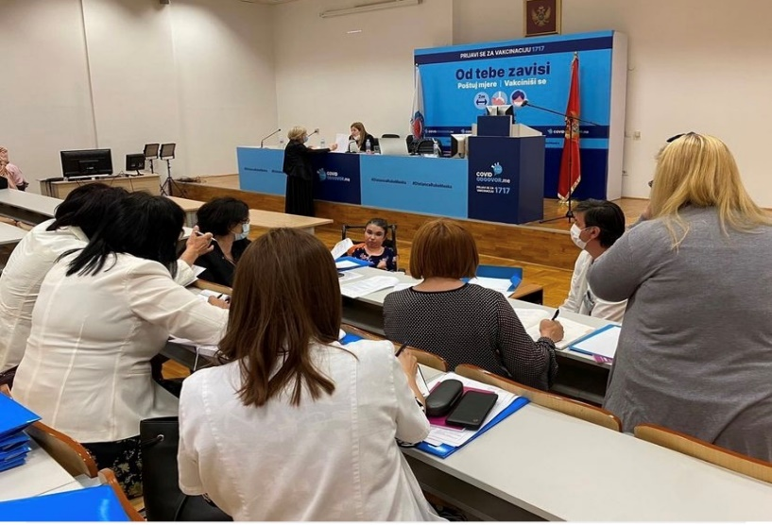
The Institute for Public Health established five expert task force groups covering different types of impairments: physical, mental, intellectual and sensory impairments, as well as a dedicated group for autism spectrum disorder. Some task force groups were further divided into smaller sub-groups to address specific assessment needs of children and adults. The work of the groups was coordinated by the Institute for Public Health, with continuous technical support from UNDP consultants.
To ensure a multidisciplinary and participatory approach, the task force groups included professionals from the existing assessment system, medical specialists from different fields, psychologists, social workers, physiotherapists, occupational therapists, as well as representatives of organizations of persons with disabilities and parents of children with disabilities. This ensured that development of the methodology combined professional expertise with lived experience of persons with disabilities and their families.
Given the limited availability of international guidance on operationalizing the UN CRPD standards and principles in disability assessment systems, the Action invested significant efforts in reviewing comparative European practices and consulting with international experts, United Nations agencies, the Committee on the Rights of Persons with Disabilities and countries implementing similar reforms. This process informed development of a methodology tailored to Montenegro’s institutional and legal context, while remaining aligned with international standards and the principles of the UN CRPD.
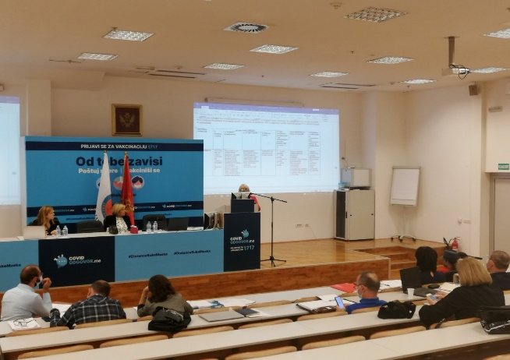
As a result, the Action supported development of the key components of the new disability assessment methodology. The List of Impairments and the List of Functional Limitations were developed based on internationally recognized frameworks, including the International Classification of Diseases and the International Classification of Functioning, Disability and Health. In addition, the World Health Organization Disability Assessment Schedule 2.0 was introduced to support assessment of functioning of adults in their everyday environment, while a dedicated questionnaire for assessing functioning of children was developed to reflect the specific needs of children with disabilities.
The introduction of functional assessment questionnaires represented an important step in moving beyond diagnosis-based assessment towards a more comprehensive understanding of disability, including functioning, environmental barriers and participation. The new methodology was designed to determine disability status through a combined assessment of impairment and functional status, thereby strengthening the transition towards a rights-based and person-centred model of disability assessment.
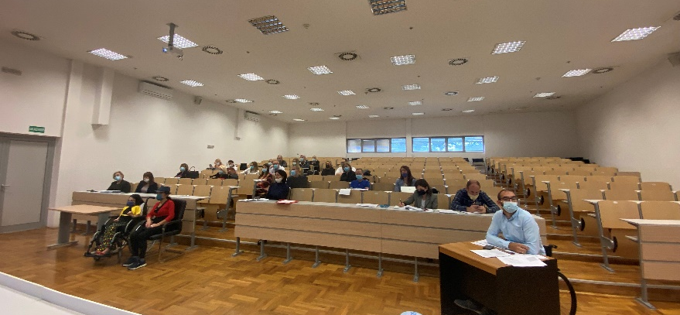
Beyond the outputs initially foreseen in the results framework, the Action also supported development of a third component of the methodology — the Needs Assessment Questionnaire. This tool was designed to identify individual support needs of persons with disabilities and provide an evidence base for planning future support services, benefits and policy measures. Its development represented an important added value of the Action and further strengthened alignment of the new system with the human-rights-based approach to disability.
The independent final evaluation recognized development of the new methodology as one of the project’s most important achievements, noting that it established the basis for a unified, functional and rights-based disability assessment model in Montenegro. While final alignment of some methodological components depended on adoption of the legal framework, the Action established the essential technical foundations for implementation of the new disability determination system.
Activity 1.3. Creation and adoption of new normative framework, encompassing law and bylaws
The development and adoption of the new normative framework represented the core legal component of the Action and a prerequisite for the establishment of a unified disability determination system. This activity included preparation of the Law on Uniform Disability Assessment, harmonization of sectoral legislation, development of accompanying by-laws and preparation of the Regulatory Impact Analysis.
At the initial stage, UNDP engaged a legal expert to prepare an analysis of the existing legal framework and propose amendments to relevant legislation governing disability assessment across different sectors. Based on this analysis, the first draft of the Law on Uniform Disability Assessment was prepared and presented to the Intersectoral Working Group. Following comments and suggestions from institutions and organizations of persons with disabilities, the Working Group continued to refine the draft law through several rounds of consultations.
In July 2022, work on the draft law was intensified through joint and bilateral consultations with relevant sectors and organizations of persons with disabilities. These consultations were particularly important due to the complexity of harmonizing the new unified approach with existing sectoral systems, including social protection, education, employment, pension and disability insurance, and veterans’ protection. In parallel, the Regulatory Impact Analysis was prepared in close consultation with relevant sectors and local-level representatives, based on financial inputs provided by institutions. The analysis assessed the existing situation, possible policy options and projected costs for establishing the new institutional framework over a three-year period. Together with the draft law and accompanying explanatory documents, it provided an important basis for consideration and adoption of the Draft Law by the Intersectoral Working Group in November 2022, followed by a public discussion held from 21 November to 12 December 2022, including a public roundtable organized at the UN Eco House.
After the public discussion, comments received from stakeholders were reviewed and incorporated, while the draft law and accompanying documents, including the Regulatory Impact Analysis and Explanatory Note, were submitted to relevant institutions for formal opinions and endorsement. The overall process was affected by several external and institutional factors, including frequent changes in government structures, institutional restructuring, changes of focal points in relevant ministries and a cyber-attack on public administration digital infrastructure, which temporarily disrupted communication with institutions. In addition, the alignment process proved considerably more complex and lengthier than initially expected. This was due to limited political continuity and ownership at certain stages of the reform, the need to harmonize the new legal framework with several sectoral laws, and the extended consultation and alignment process with the Secretariat for Legislation, which lasted almost three years.
Despite these challenges, the Action maintained legal and technical support throughout the process. In parallel, a smaller technical task force composed of legal representatives of relevant sectors was established to support drafting of the Decree on disability assessment and related by-laws, while ensuring that all documents would be subsequently discussed and validated through the Intersectoral Working Group. During the final stage of the legislative process, the Action also supported preparation of amendments to seven sectoral laws required for their harmonization with the Law on Uniform Disability Assessment. This work was carried out within a compressed timeframe, following the renewed institutional momentum to finalize the reform package and enable its submission for adoption.
A major achievement was reached during the final year of project implementation, when the Parliament of Montenegro adopted the Law on Uniform Disability Assessment, together with amendments to seven sectoral laws regulating social protection, education, labour and employment, pension and disability insurance, veterans’ protection and travel benefits for persons with disabilities. This legislative package created the legal basis for the establishment of the Institute for Disability Assessment and introduced standardized, person-centred procedures for disability assessment across all relevant sectors.
In parallel, the Action supported preparation of key by-laws required for operationalization of the new system, including drafts of the Decree on the unified methodology for disability assessment, the Decision on establishment of the Institute for Disability Assessment, the Statute of the Institute, the Rules of Procedure of the Management Board, the Rulebook on the composition and work of disability assessment commissions and the Rulebook on internal organization and systematization of the Institute. These documents provide the basis for the next phase of implementation and the operational launch of the new disability determination system.

Result Area 2: Institutional rightsizing and reorganization

Activity 2.1. Commission established, staffed and supported
This activity was not completed within the duration of the Action, as the establishment, staffing and operational support of the Institute for Disability Assessment were dependent on the prior adoption and entry into force of the Law on Uniform Disability Assessment and are therefore expected to continue in the post-project phase.
Activity 2.2. Adaptation and equipping of the premises
Adaptation and equipping of the premises for the Institute for Disability Assessment was completed as one of the key institutional preconditions for operationalization of the new disability determination system. Through this activity, the Action ensured that the future Institute would have functional, accessible and adequately equipped premises necessary for the implementation of unified disability assessment procedures.
The allocation of premises represented a long-standing challenge during implementation. Although the need to secure adequate space for the Institute had been raised from the beginning of the Action, the process was significantly delayed due to changes in government structures and prolonged administrative procedures. Following earlier attempts to identify and allocate suitable premises, the Government of Montenegro ultimately approved allocation of 188 m² within the Centre for Professional Rehabilitation for the future Institute. The agreement on use of the premises was signed in December 2024, enabling the Action to proceed with reconstruction and equipping.
Following formal allocation of the space, the Action supported the full process of preparing technical documentation, designing the reconstruction and furnishing solution, and implementing adaptation works in line with the functional requirements of the future Institute and accessibility standards. Although the scope and cost of works increased compared to the initial budget due to rising construction prices and the need for substantial adaptation of the allocated space, the project reallocated available resources to ensure that this critical institutional precondition was fulfilled. By the end of the Action, premises for the Institute had been reconstructed and equipped with furniture necessary for its initial functioning. This result created the physical and operational basis for the establishment of the Institute and represents a concrete contribution of the Action to institutionalizing the new disability determination system.
The reconstruction and equipping of the premises is an important element of institutional readiness for the new system, alongside the adopted legal framework and developed methodology.
Activity 2.3. Civil servants trained for application of the new assessment and determination system
This activity was not completed within the duration of the Action, as the establishment, staffing and operational support of the Institute for Disability Assessment were dependent on the prior adoption and entry into force of the Law on Uniform Disability Assessment and are therefore expected to continue in the post-project phase.
Activity 2.4. Promotion, information sharing and education
Numerous promotion, information sharing and education activities were implemented to support public understanding of the reform, strengthen ownership among persons with disabilities and their representative organizations, and promote the transition from a medical model of disability towards a human-rights-based and person-centred approach. Given the scope and sensitivity of the reform, communication activities were not treated only as visibility measures, but as an integral part of the reform process, aimed at building trust, addressing concerns and ensuring that persons with disabilities and their families are informed about the purpose and expected benefits of the new system.

In line with the principle “Nothing About Us Without Us”, the Action ensured continuous participation of organizations of persons with disabilities throughout implementation. Their representatives participated in the Steering Committee, Intersectoral Working Group, expert task force groups established by the Institute for Public Health and other project structures. This approach enabled persons with disabilities and their representative organizations to contribute not only to communication activities, but also to the design of the legal, methodological and institutional solutions developed under the Action.
A key instrument for strengthening outreach and community-level engagement was the first Call for Proposals, launched in June 2021 following approval by the Steering Committee. Through this mechanism, the Action supported five civil society initiatives, four of which were implemented by organizations of persons with disabilities. A total of EUR 49,542 was allocated to projects focused on promotion of disability rights, inclusive terminology, accessibility, anti-discrimination, employment, gender equality, social inclusion and the shift towards a rights-based understanding of disability.
The supported initiatives contributed to a broader and more informed public debate on disability rights and disability assessment reform. They combined direct engagement with persons with disabilities and their families, targeted education of professionals and local institutions, media outreach and production of accessible communication materials. Activities included workshops, webinars, public discussions, video materials, podcasts, personal stories, legal support, publications and media campaigns. Through these interventions, the Action reached persons with different types of disabilities, including persons in institutions, persons with psychosocial and intellectual disabilities, sensory impairments, older persons with disabilities, parents and family members, as well as local service providers, journalists and the wider public.
The grant scheme also generated important qualitative results. It helped bring disability assessment reform closer to communities, opened space for persons with disabilities to share their experiences, strengthened capacities of organizations of persons with disabilities to communicate reform messages, and contributed to reducing stigma and misconceptions about disability. The involvement of organizations with direct links to beneficiary communities made communication more credible, accessible and responsive to the concerns of persons most affected by the reform.
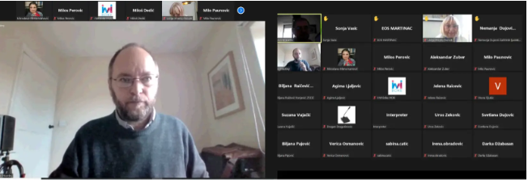
In addition to community outreach, the Action supported knowledge exchange and capacity strengthening of stakeholders involved in the reform. A webinar on development of a rights-based disability assessment system, delivered by an international disability policy expert, provided members of working groups and professionals involved in the reform with comparative insights from European disability assessment systems and practical guidance on aligning assessment models with the United Nations Convention on the Rights of Persons with Disabilities.

The second Call for Proposals, initially planned to support a comprehensive campaign on the new assessment procedures, was postponed due to delays in adoption of the legal framework. Following adoption of the Law on Uniform Disability Assessment and amendments to seven sectoral laws, communication efforts were redirected towards explaining the adopted legal changes and preparing beneficiaries and institutions for the introduction of the new system. In the final reporting period, the Action supported organization of a national conference and three regional info days in Podgorica, Bijelo Polje and Bar. These events provided direct information to persons with disabilities and their families on the key novelties introduced by the reform and created a channel for collecting questions, concerns and information needs from beneficiaries.
To ensure broader dissemination of information, the Action supported preparation of communication materials, media and social media outreach, development of a questions-and-answers document based on the issues raised during info days, and production of animated video material explaining the purpose and results of the reform. These activities helped translate a complex legal and institutional reform into accessible information for beneficiaries, institutions and the wider public.
Overall, promotion, information sharing and education activities contributed to strengthening transparency, public understanding and participatory ownership of the reform. They supported the visibility of the new disability determination model, promoted a rights-based understanding of disability and reinforced the role of organizations of persons with disabilities as key partners in implementation and monitoring of the reform. The independent final evaluation recognized that participation of organizations of persons with disabilities “strengthened legitimacy, transparency and accountability of the reform process” and contributed to embedding participatory governance practices in the new system.
Activity 2.5. Information System developed and implemented
Due to delays in adoption of the legal framework, full development and deployment of the information system could not be completed within the duration of the Action. However, the project supported key preparatory steps for its future development, including preparation of technical specifications and procurement of hardware for the Institute for Disability Assessment. These outputs provide an important basis for the next phase of implementation, once the Institute becomes operational and detailed procedures are fully in place.
In line with the conclusions of the final Steering Committee meeting, the Action also supported two additional activities aimed at facilitating implementation of the reform and strengthening its linkage with the Reform Agenda. First, a vehicle was procured for the future Institute, taking into account that disability assessment commissions will, where needed, conduct field visits in order to make the assessment process more accessible to persons with disabilities. This will support outreach to beneficiaries who may face difficulties accessing the Institute’s premises and contribute to a more user-centred implementation of the new system.
Second, the Action engaged a consultant to prepare an analysis of existing methodologies for assessing increased costs of living of persons with disabilities. The analysis is intended to support implementation of Reform Agenda measure 3.1.3, related to the establishment of a unified and inclusive disability-related cash transfer, the Inclusive Allowance. By supporting this analytical work, the project contributed to creating an evidence base for future policy decisions on disability-related benefits and to ensuring stronger coherence between the disability determination reform and broader social protection reform priorities.
Activity 2.6. Piloting of the new assessment and determination system performed
This activity was not implemented within the duration of the Action, as piloting depended on the prior adoption of the Law on Uniform Disability Assessment, adoption of accompanying by-laws, formal establishment and staffing of the Institute for Disability Assessment, and availability of operational procedures. Due to the prolonged legal harmonization process and delayed adoption of the legal framework, these preconditions were not in place early enough to conduct a meaningful pilot, and the activity is therefore expected to continue in the post-project phase.

Independent Final Evaluation
In the final stage of implementation, an independent final evaluation of the Action was conducted. The evaluation assessed the relevance, effectiveness, efficiency, sustainability and impact of the project, as well as the integration of human rights, gender equality and Leave No One Behind principles. Its findings confirmed the strategic relevance of the reform, substantial progress achieved in establishing the legal, methodological and institutional foundations of the new system, and the importance of continued support to operationalization of the Institute for Disability Assessment in the post-project phase. The independent final evaluation report is available at UNDP Independent Evaluation Office platform.

DIFFICULTIES ENCOUNTERED AND MEASURES TAKEN TO OVERCOME PROBLEMS AND EVENTUAL CHANGES INTRODUCED

The implementation of the Action took place in a highly complex and dynamic institutional environment. As a systemic reform involving five sectors, numerous institutions, several levels of decision-making and organizations of persons with disabilities, the project required continuous coordination, legal harmonization and sustained political ownership. Over the implementation period, the Action was affected by external and institutional challenges, including the COVID-19 pandemic, frequent changes of government, repeated restructuring of line ministries, changes of institutional focal points, a cyber-attack on public administration digital infrastructure and prolonged legislative procedures. These factors affected the pace of implementation, particularly in relation to the adoption of the legal framework and operationalization of the new institutional model.
Despite these challenges, the Action maintained reform momentum through adaptive implementation, continuous technical support and regular engagement with relevant stakeholders. As also noted in the independent final evaluation, frequent government changes and institutional restructuring affected continuity and ownership, while UNDP’s sustained technical engagement contributed to preserving coherence and stability of the reform process.
The most significant implementation challenge related to the development and adoption of the Law on Uniform Disability Assessment. The legal drafting process required extensive consultations and alignment among sectors with different mandates, procedures and institutional practices, particularly those traditionally based on medical assessment models. Following adoption of the draft law by the Intersectoral Working Group in November 2022, the formal alignment process with relevant institutions and the Secretariat for Legislation proved considerably more complex and lengthier than expected, requiring an extended interinstitutional alignment process, lasting almost three years.
To mitigate these delays, UNDP maintained regular communication with line ministries, organized bilateral and joint consultations, provided continuous legal and technical assistance and supported the Ministry in addressing comments and requests for clarification. During the final stage of the legislative process, the Action also supported preparation of amendments to seven sectoral laws required for their harmonization with the Law on Uniform Disability Assessment. This enabled the reform package to be submitted and adopted as a coherent legislative package.
A second major challenge was the dependency of several project activities on prior adoption of the legal framework. The establishment, staffing and full operationalization of the Institute for Disability Assessment, development of the information system, staff training and piloting of the new procedures could not be fully implemented before the law entered into force. To address this sequencing issue, the project focused on preparatory work that could be completed before formal operationalization, including preparation of key by-laws, operational tools, institutional documents, technical specifications for the information system, procurement of hardware and adaptation and equipping of the premises for the future Institute.
During periods when legislative processes were delayed, the project advanced other reform streams. Work on the disability assessment methodology was intensified through review of comparative European practices, consultations with international experts and engagement of multidisciplinary expert groups established by the Institute for Public Health. This enabled the Action to complete the key methodological components, including the List of Impairments, the List of Functional Limitations, functional assessment questionnaires and the Needs Assessment Questionnaire, ensuring that the technical foundations of the new system were ready once the legal framework was adopted.
Communication and visibility activities were also adjusted to the evolving implementation context. The second Call for Proposals, originally planned to support a campaign on the new procedures, was postponed because communication on procedures could only be effective after adoption of the legal framework. Instead, the Action redirected communication efforts towards raising awareness of the reform, promoting a rights-based understanding of disability and preparing beneficiaries and institutions for the new system through human-interest stories, media engagement, consultations with organizations of persons with disabilities, a national conference and regional info days.
Given the scale of the reform and delays caused by external factors, UNDP, in consultation with the Delegation of the European Union to Montenegro and the Steering Committee, requested two no-cost extensions of the Action. The extensions enabled continuation of work on the legal framework, methodology and institutional preconditions, and provided additional time to complete final legislative and institutional steps, including adoption of the law, harmonization of sectoral legislation, adaptation and equipping of premises, and final communication activities.
While the Action faced significant and prolonged challenges, these were addressed through adaptive management, sustained technical support, continuous stakeholder engagement and strategic reallocation of resources. Although several operational components will continue in the post-project phase, the Action succeeded in delivering the core legal, methodological and institutional foundations of the reform and created the preconditions for implementation of the new unified disability determination system.
Overall, the Action established the core legal, methodological and institutional foundations necessary for implementation of the new unified disability determination system in Montenegro. Following adoption of the Law on Uniform Disability Assessment and related amendments to sectoral legislation, the next phase of reform implementation will focus on operationalization of the Institute for Disability Assessment, adoption of remaining by-laws, deployment of the information system, staff recruitment and training, and piloting of the new procedures.
The Government of Montenegro has assumed responsibility for continuation of implementation activities during the post-Action phase through the follow-up cooperation with UNDP under the second phase of support.Continued intersectoral coordination and participation of organizations of persons with disabilities will remain important for ensuring effective implementation, monitoring and further refinement of the system once operationalized.

Visibility and Communication

Communication and visibility activities were implemented throughout the Action as an integral part of the reform process. Given the complexity and sensitivity of the disability determination reform, communication was used not only to increase visibility of the EU-funded support, but also to explain the need for change, promote a human-rights-based understanding of disability, strengthen trust among persons with disabilities and their families, and support broader public acceptance of the new system.
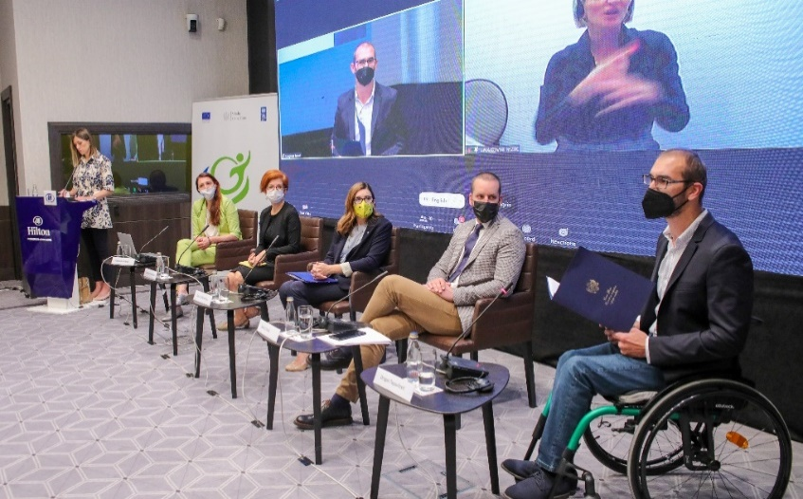
At the beginning of implementation, the project adopted a Communication and Visibility Plan, which defined key messages, target audiences, communication channels and advocacy activities with organizations of persons with disabilities. The project slogan “Prepoznaj moje mogućnosti” and visual identity were developed to support recognition of the reform and convey its central message — that disability assessment should focus on abilities, functioning, barriers and support needs, rather than solely on medical diagnoses.
The Action was officially launched through a hybrid conference held in June 2021, which gathered representatives of the Government, the European Union, UNDP, relevant institutions and organizations of persons with disabilities. The event presented the objectives of the reform, opened dialogue with key stakeholders and highlighted the importance of participation of persons with disabilities in the development of the new system. Accessibility was ensured through sign language interpretation, while the hybrid format enabled wider participation during the COVID-19 pandemic.

A dedicated mailing list of organizations of persons with disabilities and their representatives was established as an important communication tool, particularly during the pandemic and periods of limited in-person consultations. This enabled regular dissemination of information, invitations and project updates, and supported continuous engagement of representative organizations throughout implementation.

Communication activities were closely linked with the grant scheme implemented under Activity 2.4. A separate communication and visibility framework was developed for grantees in order to ensure coherence of messages, avoid overlap and increase media outreach. In addition, UNDP organized communication training for representatives of civil society organizations involved in grant implementation, strengthening their capacities to design campaigns, use communication tools and manage social media channels more effectively.
The Action also supported public dialogue during the development of the legal framework. A roundtable organized within the public discussion on the Draft Law on Uniform Disability Assessment enabled persons with disabilities, civil society, institutions and the wider public to provide comments and raise questions related to the reform. This contributed to transparency of the legal drafting process and helped address concerns of beneficiaries directly affected by the future system.
A particularly important communication result was the production and dissemination of human-interest stories presenting experiences of persons with disabilities in accessing rights under the existing fragmented assessment system. These stories illustrated, in an accessible and human-centred way, the practical consequences of inconsistent procedures, administrative burden and barriers faced by persons with disabilities and their families. At the same time, they communicated the expected benefits of the reform and contributed to a broader public understanding of why the system needed to change.

The human-interest stories were disseminated through national television, radio, online media and social media platforms, and also contributed to international visibility of the Action through UNDP regional and global communication channels, the UNDP Annual Report and the United Nations Country Results Report for Montenegro. In this way, the Action contributed not only to national awareness raising, but also to the promotion of Montenegro’s disability determination reform as a relevant example of systemic disability inclusion reform.
Throughout implementation, the project maintained active communication with media and responded to media inquiries, providing clear information on the objectives, progress and expected results of the reform. Media appearances and public communication helped keep the reform visible during periods of slower institutional progress and supported continued public interest in the process.
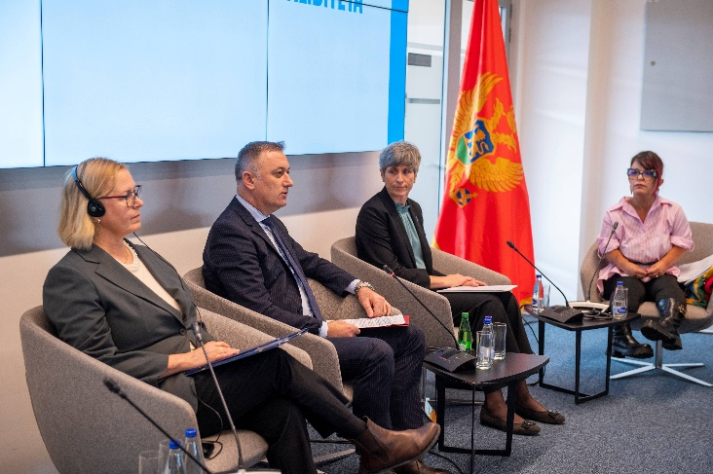
Following adoption of the Law on Uniform Disability Assessment and amendments to seven sectoral laws, communication efforts were further focused on explaining the new legal framework and preparing beneficiaries and institutions for the introduction of the new system. A national conference and three regional info days were organized to present key novelties introduced by the reform, respond to questions from persons with disabilities and their families, and collect information needs to be addressed through further communication materials.
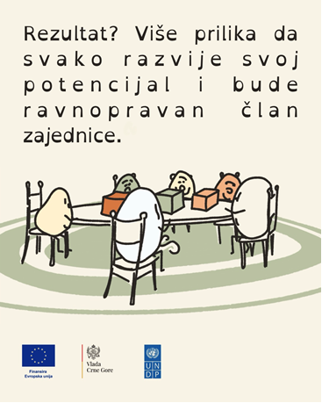
In the final stage of implementation, the Action also supported the production of an animated video explaining the purpose, key changes and expected benefits of the disability determination reform. The video was designed to present a complex legal and institutional reform in a simple, accessible and user-friendly format, targeting persons with disabilities, their families, institutions and the wider public. Following its completion, the video was promoted through institutional and project communication channels, contributing to broader understanding of the new system and further visibility of the EU-supported reform.
Overall, visibility and communication activities contributed to strengthening public understanding of the reform, promoting a rights-based approach to disability and reinforcing the role of organizations of persons with disabilities as key partners in the process. Through the grant scheme and broader communication activities, six civil society organizations, including five organizations of persons with disabilities, implemented 23 campaign activities covering at least 10 topics relevant to persons with disabilities and reaching approximately 150,000 people, thereby significantly exceeding the initially set communication indicators.
Outreach was further strengthened through two national conferences with more than 150 participants, three regional info days with 166 participants, five human-interest stories, targeted media engagement, a questions-and-answers document and animated video content. Following adoption of the Law, communication efforts were intensified through social media campaigns, carousel posts, reels and accompanying outreach materials, with digital communication activities in 2025 and 2026 reaching more than 17,000 users on Meta platforms and X.
By combining institutional communication, media engagement, civil society outreach, direct dialogue with beneficiaries and accessible visual content, the Action helped translate a complex legal and institutional reform into accessible messages for persons with disabilities, their families, institutions and the wider public.

Summary of resources deployed during the Action

During implementation, several budget reallocations were undertaken in order to respond to evolving reform priorities and implementation delays, particularly related to adaptation of premises for the future Institute for Disability Assessment and extended legal harmonization processes. Despite increased costs in certain budget lines, primarily due to inflation and increased construction prices, the Action maintained overall financial efficiency and achieved a utilization rate of 99.41% of received funds.
By the end of the implementation period, total funds received amounted to USD 1,097,343.69, while total eligible expenditure amounted to USD 1,090,876.91. The remaining balance at project closure amounted to USD 6,466.78.
Due to exchange-rate fluctuations between the euro and the US dollar, the USD-equivalent value of the contribution received was lower than originally estimated at the time of signing the Contribution Agreement. This adjustment is reflected in the Final Financial Report.
Financial implementation was carried out in line with UNDP rules and procedures and was adjusted to reflect the evolving implementation dynamics of this complex reform. The project demonstrated cost-effective delivery, responsible financial management and adaptive use of resources, despite the extended implementation period, exchange-rate fluctuations and increased costs in areas such as construction and procurement.
Resources were deployed across three main budget headings. Under Project Management, expenditure amounted to USD 361,101.86. This covered project management, coordination, financial oversight, procurement, reporting and operational support required to maintain implementation continuity throughout the extended implementation period. The expenditure under this heading was 21% higher than the received amount for this budget heading, primarily because the Action, initially designed as a 36-month intervention, was extended to 62 months. As a result, core project management, coordination and fiduciary functions had to be maintained for an additional 26 months in order to support a prolonged and highly complex reform process.
Under Development and adoption of new criteria for disability determination, expenditure amounted to USD 151,178.47. The expenditure under this heading was 13% higher than the received amount for this budget heading, primarily due to the prolonged process of developing and harmonizing the new legal and methodological framework, which required additional expert inputs, consultations and technical support over an extended implementation period. These resources supported legal and methodological expertise, preparation of the new disability assessment methodology, consultations, workshops, communication support and the institutional agreement with the Institute for Public Health. This budget heading directly contributed to development of the legal and methodological foundations of the new disability determination system.
Under Institutional rightsizing and reorganization, expenditure amounted to USD 507,050.35. Expenditure under this budget heading was 15% lower than the received amount, generating savings that were partly redirected to other priority activities in line with the needs of the reform process. This variation primarily reflects delays in the adoption of the legal framework, which affected activities dependent on the formal establishment and staffing of the Institute, including full development of the information system, piloting and complete operationalization. Nevertheless, resources under this heading supported key institutional preparations, including technical specifications for the information system, procurement of hardware, equipment and furniture, grants to civil society organizations, communication and visibility activities, and adaptation and reconstruction of the premises.
Budget adjustments were made to respond to the pace and sequencing of reform activities, allowing resources that could not be used for delayed operational components to be redirected to priority activities supporting institutional readiness. In line with the conclusions of the final Steering Committee meeting, this also included procurement of a vehicle for the future Institute and preparation of an analysis of methodologies for assessing increased costs of living of persons with disabilities, supporting the reform’s linkage with the Reform Agenda. These reallocations were made within the approved budget flexibility and without changing the overall purpose or expected results of the Action.
Although variations occurred between budget headings, the Action remained within the allowed flexibility limits under the contract. In accordance with Article 11.3 of the General Conditions, variation between two main budget headings remained within the permitted 25% threshold and did not affect the main objective, scope or expected results of the Action.
Overall, the final financial implementation shows that resources were allocated and adjusted in line with implementation needs and the evolving dynamics of the reform process. While several operational activities will continue beyond the project period, the resources deployed under the Action enabled the establishment of the legal, methodological, institutional and physical preconditions required for implementation of the new unified disability determination system.
Link to List of Grant Beneficiaries and Contracts above 15k EUR can be found here.

Annexes

Final Financial Report
List of Legal Commitments
Management Declaration
Transfer of titles can be found here.

